How to Report Monthly Influenza Vaccination Data for Dialysis Facilities

The purpose of this document is to assist dialysis facilities with reporting monthly influenza vaccination data for healthcare personnel (HCP) through CDC’s NHSN. Guidance included in this document instructs users how to use the "Weekly Influenza Reporting Module" to report monthly summaries of vaccination coverage in a dialysis facility. To meet the End-Stage Renal Disease (ESRD) reporting requirement, dialysis facilities should report cumulative influenza vaccination data for the last reporting week of each calendar month for the 2021-2022 influenza season. The deadline for entering all months of data is March 26, 2022.
Facilities are required to report data for the last reporting week of each calendar month from October 2021 through the February 2022; to meet this requirement, facilities should report vaccination data for the following weeks:
- 10/25/21 – 10/31/21
- 11/22/21 – 11/28/21
- 12/20/21 – 12/26/21
- 1/24/22 – 1/30/22
- 2/21/22 – 2/27/22

This will help facilities monitor influenza vaccination coverage during the influenza season and improve protection of HCP and patients against influenza. Please note that facilities may report more frequently, such as each week, to consistently track influenza vaccination data for the purpose of public health surveillance. For more information on the ESRD reporting requirements, please contact the ESRD QIP HelpDesk: qnetsupport-esrd@hcquis.org.
Entering Weekly Influenza Vaccination Data for HCP
Follow the instructions below to report data into the Weekly Influenza Vaccination Module.

1. Access the Healthcare Personnel Safety (HPS) Component homepage in NHSN.
2. Click on ‘Vaccination Summary’ on the left-hand navigation bar.
3. Click on the ‘Weekly Vaccination Summary’ option on the left-hand navigation bar.

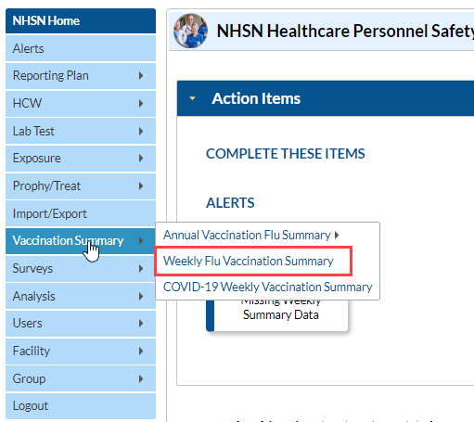

4. To report weekly influenza vaccination data, click on the week for which you wish to report data.

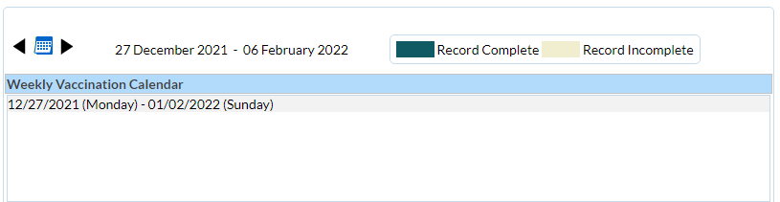
5. Enter data and be sure to click ‘Save’ at the bottom of the data entry screen. Entries will appear green once they are completed and yellow if the entry is incomplete.
6. Please note that facilities may receive a notification on their screen if data are not entered correctly. Soft alerts represent possible data entry errors and do not prohibit the user from saving their data, while hard alerts represent violation of the data reporting protocol and will prevent the user from saving their data.

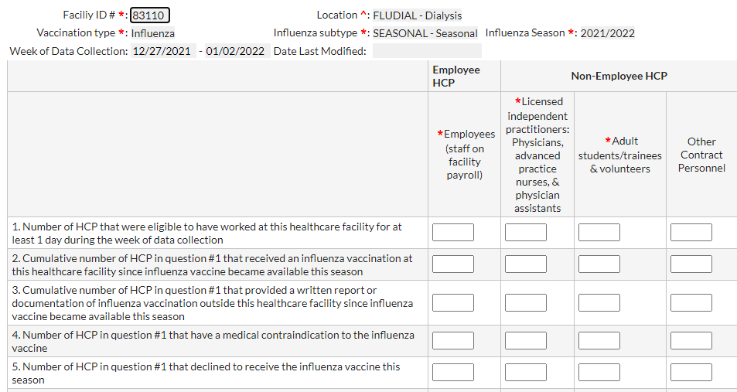Resources
- Training materials, such as the data collection form, table of instructions for completion of the form, and presentation slides are available at: HCP Flu Vaccination | HPS | NHSN | CDC.
- Please send any questions via e-mail to: nhsn@cdc.gov with ‘Weekly Flu Summary’ in the subject line.

